

**Project Report**

1 INTRODUCTION

* 1. Overview

**Logo serve to represent a given organization or company through a visual image that can be easily understood and recognized logos are often created by a graphic artist in consultation with a company and marketing experts.**

* 1. Purpose

**Logos are a point of identification; they're the symbol that customers use to recognize your brand.**

2 Problem Definition & Design Thinking

2.1 Empathy Map

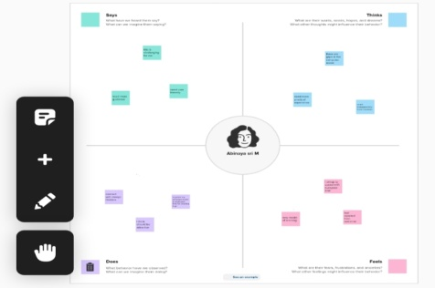

2.2 Ideation & Brainstorming Map

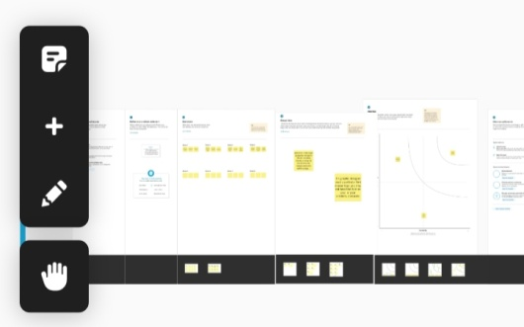

1. RESULT



1. ADVANTAGES & DISADVANTAGES
2. **It Makes a Strong First Impression**
3. This is because a different set of customers may not react well to your **logo** simply ignore it.
4. APPLICATIONS

Such a symbol may not be able to evoke any meaningful response from the viewers as it has lost its novelty value.

1. CONCLUSION

This is very useful to me. I learned about canva. This is useful to my future self employment.